### IPL AUCTION

**IPL AUCTION**

**A PROJECT REPORT**

***Submitted by***

### KARTHIKEYAN S 727821TUEC104

***in partial fulfillment for the award of the degree of***

### BACHELOR OF ENGINEERING IN

**DEPARTMENT OF COMPUTER SCIENCE AND ENGINEERING**

### June 2023

**BONAFIDE CERTIFICATE**

Certified that this project report **“PROJECT TITLE”** is the bonafide work of

### “KARTHIKEYAN S” who carried out the project work under my supervision.

#### SIGNATURE SIGNATURE

**Dr.M.KARTHIGAI PANDIAN**

#### MANOJ KUMAR.R HEAD OF THE DEPARTMENT

IAM NEO

COIMBATORE-641042 Associate Professor,

Department of Computer Science

and Engineering

Sri Krishna College of Technology,

Coimbatore-641042.

Certified that the candidates were examined by us in the Project Work Viva Voce examination held on at Sri Krishna College of Technology, Kovaipudur, Coimbatore -641042

### INTERNAL EXAMINER EXTERNAL EXAMINER

***ACKNOWLEDGEMENT***

### ACKNOWLEDGEMENT

First and foremost, we thank the **Almighty** for being our light and for showering his gracious blessings throughout the course of this project.

We are grateful to our beloved Principal **Dr.M.G. Sumithra M.E., Ph.D**. for her tireless and relentless support.

We extend our sincere thanks to our Head of the Department **Dr.R.Vidhya M.Tech., Ph.D.** for her encouragement and inspiration.

We are greatly indebted to our Industry Mentor **Mr.Manoj Kumar**  for his valuable guidance and suggestions in all aspects that aided us to ameliorate our skills.

We are thankful to all those who have directly and indirectly extended their help to us in completing this project work successfully.

# ABSTRACT



iv

## ABSTRACT

The Indian Premier League (IPL) auction is a highly anticipated and meticulously orchestrated event that takes place annually in the world of cricket. It serves as a platform where team franchises engage in a fast-paced bidding war to acquire players from a pool of both domestic and international cricketing talent. This abstract provides an overview of the IPL auction, highlighting its significance, structure, and implications for team strategies and player careers.

The IPL auction plays a crucial role in shaping the composition of teams participating in the tournament. Franchise owners, team management, and coaches carefully analyze player performances, skillsets, and market value before formulating bidding strategies. With a limited budget, teams strategically allocate their funds to secure players who can contribute to their success on the field and generate fan support off the field. The auction's competitive nature often results in intense bidding wars, making it a captivating spectacle for cricket enthusiasts worldwide.

# TABLE OF CONTENTS



**TABLE OF CONTENT**

|  |  |  |
| --- | --- | --- |
| **CHAPTER.NO** | **TITLE** | **PAGE NO** |
|  | **ABSTRACT** | **iv** |
|  | **LIST OF FIGURES** | **vi** |
|  | **LIST OF ABBREVIATIONS** | **vii** |
| 1 | 1.2 OVERVIEW | 3 |
|  | 1.3 OBJECTIVE | 3 |
| 2 | LITERATURE SURVEY | 4 |
| 3 | SYSTEM SPECIFICATIONS | 6 |
| 4 | PROPOSED SYSTEM | 9 |
|  | 4.1 PROPOSED SYSTEM | 9 |
|  | 4.2 ADVANTAGES | 12 |
| 5 | METHODOLOGIES | 15 |
|  | 5.1 LOGIN PAGE | 16 |
|  | 5.2 SIGN UP PAGE | 17 |
|  | 5.3 HOME PAGE | 18 |
|  | 5.4 AUCTION LIST PAGE | 19 |
|  | 5.5 FACTS PAGE | 20 |
|  | 5.6 QUERY PAGE | 20 |
| 6 | IMPLEMENTATION AND RESULT | 21 |
| 7 | CONCLUSION AND FUTURE SCOPE | 42 |
|  | 7.1 CONCLUSION | 42 |
|  | 7.2 FUTURE SCOPE | 44 |
| 8 | REFERENCES | 46 |

# LIST OF FIGURES



vi

**LIST OF FIGURES**

|  |  |  |
| --- | --- | --- |
| **Figure No** | **TITLE** | **Page No** |
| 5.1 | Process flow diagram | 15 |
| 5.2 | Login page flowchart | 16 |
| 5.3 | Signup page flowchart | 17 |
| 5.4 | Home page flowchart | 18 |
| 5.3 | Auction List flowchart | 19 |
| 5.4 | Facts page flowchart | 20 |
| 5.5 | Query page flowchart | 20 |
| 6.1 | Login Page | 21 |
| 6.2 | Signup Page | 22 |
| 6.4 | Home page | 23 |
| 6.5 | Auction List page | 24 |
| 6.6 | Facts page | 25 |
| 6.7 | Query page | 26 |
| 6.8 | Data page | 27 |

# LIST OF ABBREVIATIONS



vii

### LIST OF ABBREVIATIONS

#### ABBREVIATIONS

**ACRONYMS**

**HTML** HYPERTEXT MARKUP LANGUAGE

**CSS** CASCADING STYLESHEET

**JS** JAVASCRIPT

**PC** PERSONAL COMPUTER

# INTRODUCTION



1

## CHAPTER 1 INTRODUCTION

The IPL auction, short for the Indian Premier League auction, is an annual event that takes place in the world of cricket. It is a high-profile auction where franchises participating in the Indian Premier League (IPL) bid on players to form their teams for the upcoming season. The IPL is a professional Twenty20 cricket league held in India, featuring teams from different cities and regions.

The IPL auction serves as a platform for team owners to acquire the best cricketing talent from around the world. It provides an opportunity for players to showcase their skills and earn substantial contracts with the franchises. The auction is a highly anticipated event, attracting significant media attention and generating intense excitement among fans.

During the IPL auction, players are categorized into different groups based on their playing experience and skills. The auction usually includes categories such as capped players (those who have represented their national teams), uncapped players (emerging talents who haven't played for their national teams), and overseas players (players from outside India). Each franchise has a budget cap, limiting the total amount they can spend on acquiring players.

The auction process typically involves intense bidding wars between franchises, with team owners and management strategizing to secure the best possible combination of players within their budget. The bidding takes place in a live event, where team representatives raise paddles with player names to indicate their interest in acquiring them. The highest bidder for a player wins the auction and signs a contract with the franchise for the upcoming IPL season.

The IPL auction has been instrumental in providing opportunities to young, talented players to make their mark in the cricketing world. It has also allowed established international players to gain exposure to Indian conditions and compete against some of the best players in the world.

2

Overall, the IPL auction is a captivating event that not only shapes the composition of IPL teams but also captures the imagination of cricket enthusiasts worldwide, making it a significant highlight in the cricketing calendar.

3

### PROBLEM STATEMENT

How can we create a website that allows customers to customize their own PCs based on their individual needs, while also providing them with the best possible customer service?

### OVERVIEW

This report discusses the result of the work done in development for the pc customization and e-commerce on react platform. It is a react project that mainly aims in providing a common platform for facilitating an online service of buying customized PCs at the affordable price.

### OBJECTIVE

The objective of the PC customisation ecommerce website is to provide customers with a platform to customize their PCs according to their individual needs and preferences. The website should be able to offer a wide range of components and peripherals, such as graphics cards, processors, RAM, hard drives, cooling systems, and cases, as well as allow customers to assemble and configure their PCs according to their specifications. Furthermore, the website should provide customers with access to reviews and advice from experts in the field, and provide services such as installation, maintenance, and troubleshooting.

# LITERATURE SURVEY



## CHAPTER 2 LITERATURE SURVEY

4

### 2.1 RELATED WORKS

1. Academic Research: Search for academic articles or research papers that analyze the IPL auction from various perspectives, such as economics, sports management, and marketing. Topics of interest may include player valuation models, auction strategies, financial implications, and the impact of the auction on team performance and fan engagement.

2. Sports Business and Management Journals: Look for articles in sports management and business journals that discuss the IPL auction's management strategies, financial aspects, branding, and the impact on franchise profitability. These publications often offer insights into the business side of the auction and its implications for the league as a whole.

3. Media Coverage: Explore articles and reports from reputable sports news outlets, both print and online, which provide in-depth coverage of the IPL auction. These sources often offer analysis, expert opinions, and behind-the-scenes information on the auction process, player signings, and team strategies.

4. Official IPL Publications: Check official publications, reports, and press releases from the Indian Premier League governing body, as they may provide detailed information on the auction rules, regulations, and updates.

5

5. Sports Analytics and Data-driven Insights: Look for sources that apply statistical analysis and data-driven approaches to evaluate the performance and value of players acquired through the IPL auction. These analyses can provide insights into player performance, return on investment, and strategies for maximizing team strength within budget constraints.

Remember to focus on recent literature to ensure you have the most up-to-date information. Additionally, consider exploring social media platforms and online forums where cricket enthusiasts and experts discuss the IPL auction, as these sources can provide valuable perspectives and real-time discussions on the topic.

Please note that the availability of literature and research on the IPL auction may vary, and you may need to adapt your search strategy accordingly.

# SYSTEMSPECIFICATION



## CHAPTER 3

6

## SYSTEM SPECIFICATION

In this chapter, we are gonna see the softwares that we have used to build the website. This chapter gives you a small description about the softwares used in the project.

### 3.1 VS CODE

Visual Studio Code is a source code editor developed by Microsoft for Windows, Linux, and macOS. It includes support for debugging, embedded Git control, syntax highlighting, intelligent code completion, snippets, and code refactoring. It is also customizable, so users can change the editor's theme, keyboard shortcuts, and preferences. VS Code is available for Windows, macOS, and Linux, making it accessible to developers across different operating systems. VS Code is known for its lightweight and fast performance. It offers a minimalistic interface, allowing developers to focus on their code. Additionally, it provides a wide range of extensions and plugins to enhance functionality, enabling developers to **c**ustomize their development environment according to their needs. VS Code incorporates IntelliSense, an intelligent code completion feature that provides suggestions and autocompletion for variables, functions, and APIs based on the context. This feature significantly improves coding efficiency and helps prevent syntax errors.

### 3.2.REACT

7

React is a JavaScript library created by Facebook for building user interfaces. It is a component-based, declarative, and highly efficient library that is used to develop interactive UIs (user interfaces) for single page web applications. React uses a virtual DOM (Document Object Model) that makes it faster and easier to manipulate the DO

### ROUTERS IN REACT

Routers are important components in React applications. They provide the ability to navigate between different views or components of the application. React Router is the most popular library to handle routing in React applications. It provides the ability to define routes, set up links, and render components based on the current route. It also provides features like data fetching, code-splitting, and server-side rendering.

### LOCAL STORAGE

Local storage is a type of web storage for storing data on the client side of a web browser. It allows websites to store data on a user’s computer, which can then be accessed by the website again when the user returns. Local storage is a more secure alternative to cookies because it allows websites to store data without having to send it back and forth with each request. Local storage is a key-value pair storage mechanism, meaning it stores data in the form of a key and corresponding value. It is similar to a database table in that it stores data in columns and rows, except that local storage stores the data in the browser rather than in a database. Local storage is often used to store user information such as preferences and settings, or to store data that is not meant to be shared with other websites. It is also used to cache data to improve the performance of a website. Local storage is supported by all modern web browsers, including Chrome,

Firefox, Safari, and Edge. It is accessible through the browser’s JavaScript API. Local storage is a powerful tool for websites to store data on the client side. It is secure, efficient, and can be used to store data that does not need to be shared with other websites.

8

Local Storage is a great way to improve the performance of a website by caching data. Local storage in web browsers allows website data to be stored locally on the user’s computer. It is a way of persistently storing data on the client side, which is not sent to the server with each request. This allows users to store data such as preferences, login information, and form data without needing to send it to a server. It is typically stored in a browser’s cookie file, but it can also be stored in other locations such as HTML5 Local Storage and IndexedDB. The data stored in local storage is persistent and can be accessed by the website even if the user closes the browser or navigates to another page. It is a great way for websites to store user-specific data, as it is secure, reliable, and fast. It is also a great way for developers to store data that does not need to be sent to the server with each request.

One of the key benefits of using local storage is its reliability. Unlike server-side storage, which can be affected by network outages or other server issues, local storage is stored locally on the user’s machine, and so is not affected by these issues. Another advantage of local storage is its speed. Because the data is stored locally, it is accessed quickly, as there is no need to send requests to a server. This makes it ideal for storing data that needs to be accessed quickly, such as user preferences or session data. Local storage is also secure, as the data is stored on the user’s machine and not on a server. This means that the data is not accessible by anyone other than the user, making it a good choice for storing sensitive information.

# PROPOSED SYSTEM



9

## CHAPTER 4 PROPOSED SYSTEM

This chapter gives a small description about the proposed idea behind the development of our website

### PROPOSED SYSTEM

Develop a dedicated online platform for conducting the IPL auction. This platform should provide a secure and user-friendly interface for franchises, players, and auction administrators to participate in the auction process remotely.

Implement a real-time bidding system that allows franchises to place bids on players during the auction. The system should display the current bid amount, notify participants of new bids, and enforce bid increments to ensure fair competition.

Design an algorithm that calculates the value of players based on various performance indicators, such as batting average, bowling economy, recent form, and player rankings. This algorithm should provide an objective assessment of player worth, helping franchises make informed bidding decisions.

Incorporate a budget management feature that enables franchises to set their maximum spending limit for the auction. The system should track and display the remaining budget of each franchise in real-time to ensure they stay within their allocated budget.

Ensure transparency in the auction process by providing visibility into the bidding history, including the name of the bidding franchise and the bid amount. This transparency helps build trust among stakeholders and reduces the potential for favoritism or collusio

10

Develop a visual representation of each franchise's team composition during the auction. This visualization should display the selected players, their positions, and any remaining slots to help franchises strategize their bidding based on their team requirements.

Integrate a system that provides real-time updates on player injuries, availability for national duties, or any other circumstances that may affect their participation in the IPL. This information can help franchises make informed decisions during the auction and plan for potential replacements if needed.

Maintain a database of historical IPL auction data, including player prices, team compositions, and performance statistics. This data can be used to perform analytics and generate insights for franchises, helping them make data-driven decisions in future auctions.

Ensure the proposed system is compatible with mobile devices, allowing users to participate in the auction through mobile applications or responsive web interfaces. This mobile compatibility increases accessibility and convenience for stakeholders.

Implement robust security measures to protect sensitive information and prevent unauthorized access to the auction platform. Comply with data privacy regulations and ensure the confidentiality of user data throughout the auction process.

11

By incorporating these features, the proposed system aims to streamline and enhance the IPL auction experience, making it more transparent, efficient, and accessible to franchises, players, and administrators.

12

### ADVANTAGES

**·** The IPL auction offers several advantages, benefiting various stakeholders involved in the tournament:

The auction provides an equal and fair opportunity for players from around the world to showcase their skills and secure contracts with IPL franchises. It opens doors for emerging talents and allows them to compete alongside established international players, helping them gain exposure, experience, and recognition.

The auction process fosters healthy competition among franchises, driving up the value of players and resulting in higher player salaries. This competition ensures that players are rewarded based on their skills, performance, and market demand.

The IPL auction acts as a platform for unearthing new talents and nurturing domestic players. Franchises scout and identify promising players, offering them opportunities to play alongside and learn from experienced international players. This exposure accelerates their development and contributes to the growth of cricket in their respective countries.

13

The IPL auction brings together players from different countries, creating a diverse and multicultural environment. This global integration helps in the exchange of cricketing knowledge, skills, and techniques, enriching the sport and promoting camaraderie among players.

The IPL auction has significant economic implications, generating revenue and boosting the local economy. The tournament attracts sponsorship deals, media rights contracts, and tourism, creating job opportunities and supporting businesses associated with the event.

The auction generates excitement and anticipation among cricket fans worldwide. It becomes a focal point of discussion and speculation, allowing fans to engage with the sport beyond the actual matches. The auction announcements and team compositions keep fans involved and invested throughout the tournament.

The auction allows franchises to strategically build their teams, selecting players who complement their playing style, fill specific positions, and enhance team dynamics. Franchises can analyze player statistics, performance history, and team requirements to create a balanced and competitive lineup.

The IPL auction attracts a vast viewership, not only from India but also from cricket fans around the globe. The auction's international appeal adds to the overall popularity and exposure of the IPL, attracting a larger audience and expanding the fan base.

14

The IPL auction follows a revenue-sharing model where a portion of the revenues generated from the tournament is distributed among the franchises and the Board of Control for Cricket in India (BCCI). This distribution helps sustain and grow the league, ensuring the financial stability of the participating teams.

The IPL auction receives extensive media coverage, generating buzz and publicity for the league and its franchises. This coverage increases brand visibility, attracting sponsors, and promoting the league's image and popularity.

Overall, the IPL auction offers a range of advantages, including fair opportunities for players, competitive bidding, talent discovery, economic growth, enhanced fan engagement, strategic team building, and global exposure for cricket. These advantages contribute to the overall success, competitiveness, and global appeal of the Indian Premier League.

# METHODGIES



## CHAPTER 5 METHODOLOGIES

15

This chapter gives a small description about how our system works.

Login Page

SignUp

Page

Home

Players List

About

Query

Fig 5.1 PROCESS FLOW DIAGRAM

### 5.1.LOGIN

16

Enter the login page

Enter the details

Details are validated

Fig 5.2. LOGIN PAGE FLOWCHART

In this page we will be asking about the username and password of the user. Firstly the website validates the user inputs. It verifies the username and password by checking it with the usernames and passwords stored in the local storage when the user creates an account in the website.

### 5.2 SIGNUP PAGE

17

Enter the signup page

Enter the details

Details are validatedd

Fig 5.3 SIGNUP PAGE FLOWCHART

This page asks users about the basic details of the user to create an account. This page asks for details like username, password,email id, phone number. After the user enters the details , these details are then validated by our code . If all details are correct then the user is then directed to the login page

18

### HOME PAGE

This Page Shows what are the pages available in the website. It helps the audience to visit the other pages in website.

Enter home page

Fig 5.3 HOME PAGE FLOWCHART

19

### AUCTION LIST

This page displays the list of players available in the auction list. This page also displays the base price of players in the auction.

Enter the players list

See the details

Fig 5.4 AUCTION LIST PAGE FLOWCHART

20

### 5.5 FACTS

This page displays the details of the web application more deeply and clearly. This page will be very useful to the audience to learn about the application.

Enter about page

See the details

Fig 5.5 FACTS PAGE FLOWCHART

### 5.6 QUERY

This page helps the audience to clarify the doubts regarding the web page.

# IMPLEMENTATIONANDRESULT



**CHAPTER 6**

21

**IMPLEMENTATION AND RESULT**

This chapter gives a description about the output that we produced by developing the website of our idea.

### 6.1 LOGIN

When User enters our website he will be asked about his login details like email id and password. The login details will be verified with the details given while the user creates an account.

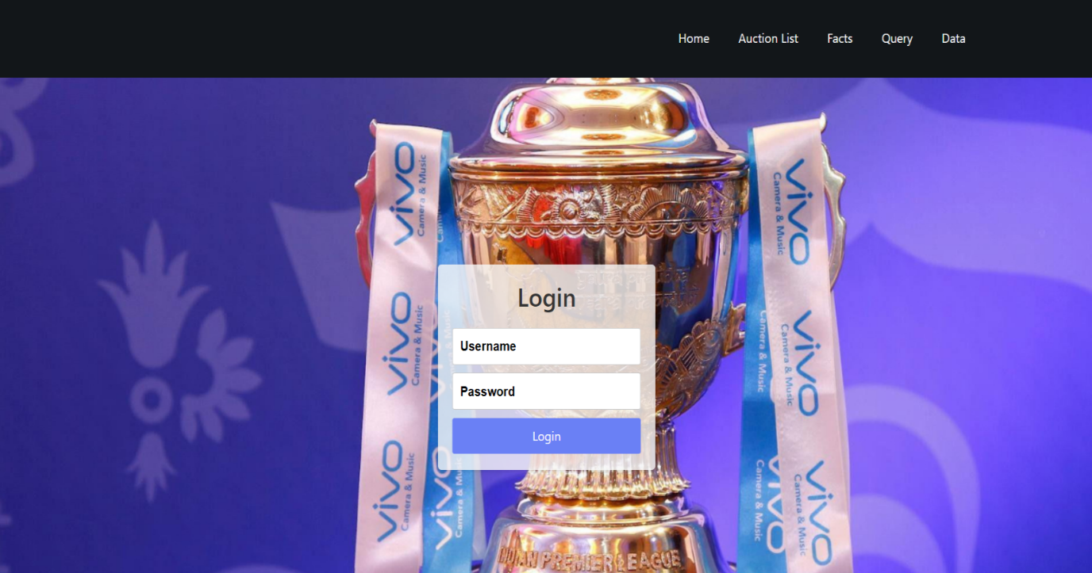

Fig 6.1 LOGINPAGE

22

### SIGN UP

If a user doesn’t have an account on the website, User can use a component named create new account available in the login page. When the user clicks on that he will be redirected to the signup page. In sign up he should fill up his email id, password and phone number. These inputs will be validated.



Fig 6.2 SIGNUP PAGE

23

### HOME PAGE

This page helps the audience to visit more pages in this web application. The user can visit all other pages with the help of this page



Fig 6.3 HOME PAGE

24

### AUCTION LIST

This page shows the list of players in the auction list. It also displays the price and nationality of the player in this page. The audience can able to see their players by using this page.

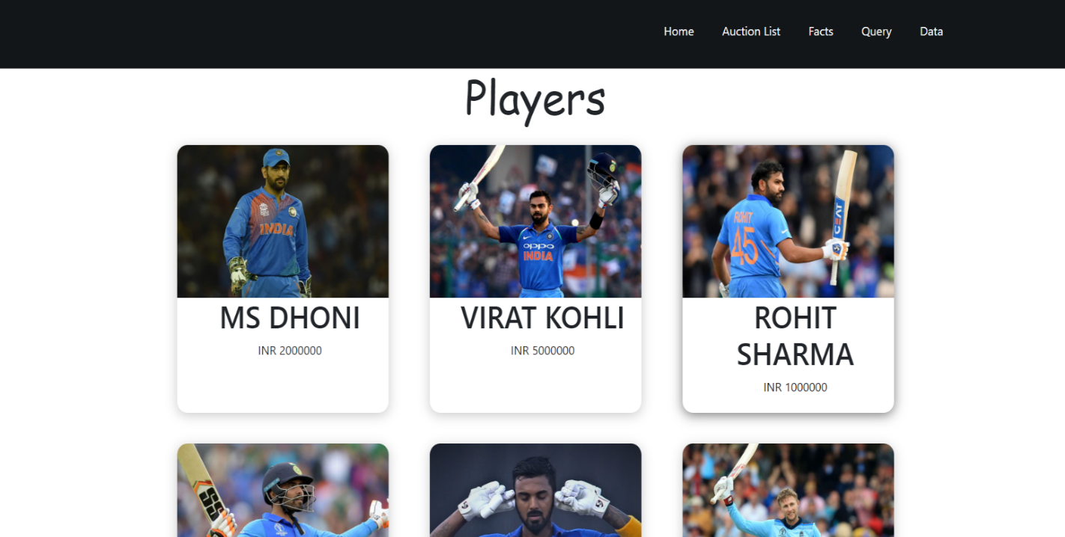

Fig 6.4 AUCTION LIST PAGE

25

### FACTS

The "Fact" page introduces the organization or project to users, giving them an overview of its purpose, mission, and values. It provides background information that helps users understand the context and goals of the entity behind the website or application.



Fig 6.5 FACTS PAGE

26

### QUERY

The "Query" page can serve as a channel for users to provide feedback, suggestions, or share their experiences. Users can submit their thoughts, ideas, or recommendations, which can help organizations improve their products, services, or processes.

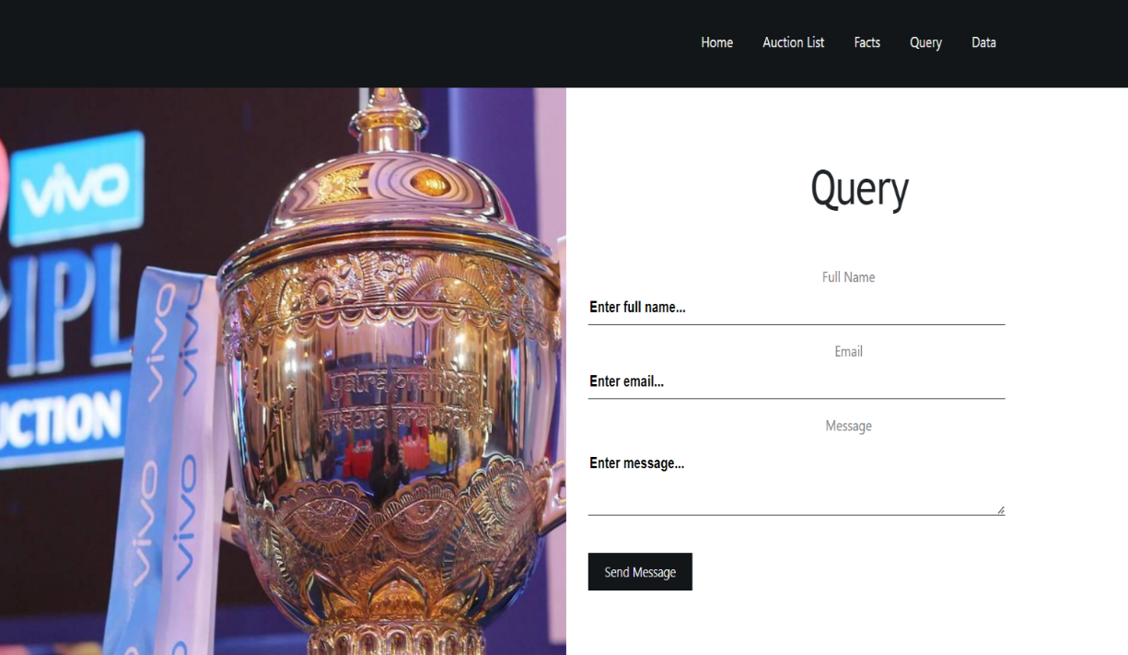

Fig 6.6 QUERY PAGE

27

### 6.2.7 DATA

This Page provides the complete details of players who are all participated in the auction list. It contains the name of the player, which team he gonna to be played, nationality, base price and sold price

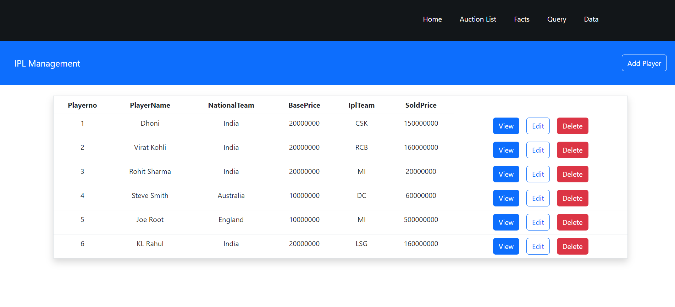

Fig6.7DETAILSPAGE

28

### 6.7 CODING

#### Login:

import React, { useState } from "react";

import axios from "axios";

import "../styles/styles.css";

import { useNavigate } from "react-router-dom";

const Login = () => {

const [username, setUsername] = useState("");

const [password, setPassword] = useState("");

const [errorMessage, setErrorMessage] = useState("");

const navigate=useNavigate();

console.log({

username,

password

})

const handleLogin = async (e) => {

try {

// Validate username and password here

29

// You can add additional validation logic here according to your requirements

if (username.trim() === "") {

setErrorMessage("Please Enter a Username");

return;

}

if(password.trim()==="")

{

setErrorMessage("Please Enter a Passord");

}

if (!/(?=.*[a-z])(?=.*[A-Z])(?=.*\d)(?=.*[@$!%*?&])[A-Za-z\d@$!%*?&]{8,}/.test(password)) {

setErrorMessage("Password should contain 8 letters with at least one uppercase letter, one lowercase letter, one digit, and one special character");

return;

}

e.preventDefault();

// Login user

const response=await axios.post("http://localhost:8080/login", {

username,

password

});

console.log(response.data)

// Redirect to the dashboard page

30

if(response.data=="Login Successful")

{

navigate("/h1");

}

else

{

setErrorMessage("You are not aregistered user.Please sign up first");

}

} catch (error) {

console.error(error);

setErrorMessage("An error occured while logging in.Please try again later");

}

};

return (

<div className="login-page">

<div className="login-container">

<h2>Login</h2>

{errorMessage && <div className="error">{errorMessage}</div>}

<input

type="text"

placeholder="Username"

value={username}

onChange={(e) => setUsername(e.target.value)}

className=" login-input"

/>

31

<input

type="password"

placeholder="Password"

value={password}

onChange={(e) => setPassword(e.target.value)}

className="login-input"

/>

<button onClick={handleLogin} className="login-button">Login</button>

</div>

<div className="animated-background"></div>

</div>

);

};

export default Login;

#### Sign up:

import React, { useState } from "react";

import axios from "axios";

import { Link,useNavigate } from "react-router-dom";

import "../styles/signup.css";

const SignUp = () => {

const navigate=useNavigate();

const [loading, setLoading] = useState(false);

const [username, setUsername] = useState("");

const [password, setPassword] = useState("");

32

const [confirmPassword, setConfirmPassword] = useState("");

const [email, setEmail] = useState("");

const [gender, setGender] = useState("");

const [age, setAge] = useState("");

const [errorMessage, setErrorMessage] = useState("");

const handleSignUp = async () => {

try {

// Check if user is already signed in

if (isUserSignedIn()) {

setErrorMessage("You are already signed in.");

return;

}

// Validate form inputs

if (username.trim() === "") {

setErrorMessage("Please enter a username.");

return;

}

if (password.trim() === "") {

setErrorMessage("Please enter a password.");

return;

}

if (password.length < 8 || !/(?=.*[a-z])(?=.*[A-Z])(?=.*\d)(?=.*[@$!%*?&])[A-Za-z\d@$!%*?&]{8,}/.test(password)) {

setErrorMessage(

33

"Password should contain at least 8 characters with at least one uppercase letter, one lowercase letter, one digit, and one special character."

);

return;

}

if (confirmPassword.trim() === "") {

setErrorMessage("Please confirm your password.");

return;

}

if (password !== confirmPassword) {

setErrorMessage("Passwords do not match.");

return;

}

if (email.trim() === "" || !/\S+@\S+\.\S+/.test(email)) {

setErrorMessage("Please enter a valid email address.");

return;

}

if (gender.trim() === "") {

setErrorMessage("Please enter your gender.");

return;

}

if (age.trim() === "" || isNaN(parseInt(age))) {

setErrorMessage("Please enter a valid age.");

34

return;

}

// Create a new user

await axios.post("http://localhost:8080/signup", {

username,

password,

email,

gender,

age: parseInt(age),

});

// Redirect to the login page

navigate("/login");

} catch (error) {

console.error(error);

setLoading(false);

}

};

const isUserSignedIn = () => {

// Implement the logic to check if the user is already signed in

// Return true if signed in, otherwise false

// You can use the appropriate authentication mechanism or state management library for this check

// For demonstration purposes, let's assume a variable named 'isSignedIn' holds the sign-in status

35

const isSignedIn = false;

return isSignedIn;

};

return (

<div className="signup-page">

<div className="signup-container" >

<h2>Sign Up</h2>

{errorMessage && <div className="error">{errorMessage}</div>}

<input

type="text"

placeholder="Username"

value={username}

onChange={(e) => setUsername(e.target.value)}

/>

<input

type="password"

placeholder="Password"

value={password}

onChange={(e) => setPassword(e.target.value)}

/>

<input

36

type="password"

placeholder="Confirm Password"

value={confirmPassword}

onChange={(e) => setConfirmPassword(e.target.value)}

/>

<input

type="email"

placeholder="Email"

value={email}

onChange={(e) => setEmail(e.target.value)}

/>

<input

type="text"

placeholder="Gender"

value={gender}

onChange={(e) => setGender(e.target.value)}

/>

<input

type="text"

placeholder="Age"

value={age}

onChange={(e) => setAge(e.target.value)}

/>

<button onClick={handleSignUp}>Sign Up</button>

<p>

Already have an account? <Link to="/login">Login</Link>

</p>

</div>

37

<div class="signup-image"></div>

</div>

);

};

export default SignUp;

#### Auction Player List:

import React from "react";

import { MenuList } from "../helpers/MenuList";

import MenuItem from "../components/MenuItem";

import "../styles/Menu.css";

function Menu() {

return (

<div className="menu">

<h1 className="menuTitle">Players</h1>

<div className="menuList">

{MenuList.map((menuItem, key) => {

return (

<MenuItem

key={key}

image={menuItem.image}

name={menuItem.name}

price={menuItem.price}

/>

);

38

})}

</div>

</div>

);

}

export default Menu;

#### Facts:

import React from "react";

import ipltrop from "../assets/ipltrop.jpg";

import "../styles/About.css";

function About() {

return (

<div className="about">

<div

className="aboutTop"

style={{ backgroundImage: `url(${ipltrop})` }}

></div>

<div className="aboutBottom">

<h1> FACTS</h1>

<p>

Auction Format: The IPL auctions follow a unique format where players from various countries and backgrounds are listed, and teams bid to acquire their services for the upcoming season.

Player Categories: Players are divided into different categories based on their playing experience and international status. Categories include capped and uncapped players, Indian and overseas players, etc.

39

Bid Strategies: Franchise owners, team management, and coaches employ different strategies during the auctions to build a balanced and competitive team within their allocated budget. Some teams focus on star players, while others prioritize emerging talents.

High Bids: Over the years, several players have fetched enormous bids at the IPL auctions. The most expensive player in IPL history is Virat Kohli, who was retained by the Royal Challengers Bangalore (RCB) for INR 17 crore (approximately $2.4 million) for the 2020 season.

Uncapped Players: The IPL auctions provide a platform for young and unknown players to showcase their skills and earn lucrative contracts. Many uncapped players have earned substantial bids and gone on to become established stars in the league.

Rapid Auctions: The auctions are known for their fast-paced nature, with players being bid on and sold within a matter of seconds. This adds an element of excitement and suspense to the event.

</p>

</div>

</div>

);

}

export default About;

40

#### Query:

#### import React from "react";

#### import contact from "../assets/contact.jpg";

#### import "../styles/Contact.css";

#### function Contact() {

#### return (

#### <div className="contact">

#### <div

#### className="leftSide"

#### style={{ backgroundImage: `url(${contact})` }}

#### ></div>

#### <div className="rightSide">

#### <h1> Query</h1>

#### <form id="contact-form" method="POST">

#### <label htmlFor="name">Full Name</label>

#### <input name="name" placeholder="Enter full name..." type="text" />

#### <label htmlFor="email">Email</label>

#### <input name="email" placeholder="Enter email..." type="email" />

#### <label htmlFor="message">Message</label>

#### <textarea

#### rows="6"

#### placeholder="Enter message..."

#### name="message"

#### required

#### ></textarea>

#### <button type="submit"> Send Message</button>

#### </form>

41

#### </div>

#### </div>

#### );

#### }

#### export default Contact;

# CONCLUSION



42

## CHAPTER 7 CONCLUSION

This chapter tells about the conclusion that anyone can drive from the project and the learning we learnt by taking over this project.

### CONCLUSION

The Indian Premier League (IPL) is a professional Twenty20 cricket league in India that has gained immense popularity since its inception in 2008. After considering the various aspects and impact of the IPL, here are a few key conclusions:

The IPL has been a massive commercial success, generating substantial revenue for both the Board of Control for Cricket in India (BCCI) and the participating franchises. It has attracted significant investments from corporate sponsors and broadcasters, making it one of the richest cricket leagues globally.

The IPL has helped in popularizing cricket beyond traditional cricket-playing nations. With its glitz, glamour, and high-quality cricket, the tournament has captivated audiences not only in India but also across the world. It has played a crucial role in expanding the fan base and commercial viability of cricket as a global sport.

The IPL has provided a platform for young and domestic cricket talents to showcase their skills and compete alongside international stars. It has acted as a breeding ground for nurturing young talent and identifying future stars, contributing to the development of cricket at the grassroots level in India.

43

The IPL is not just about cricket; it is also a form of entertainment. The tournament combines cricket with various forms of entertainment, including music, dance performances, and celebrity appearances. This unique blend has attracted a diverse audience, including casual sports fans, who enjoy the spectacle and excitement of the event.

Like any major sporting event, the IPL has faced its share of controversies and challenges. Issues such as match-fixing allegations, conflicts of interest, and controversies surrounding team ownership have marred the tournament's reputation at times. However, the BCCI has taken steps to address these issues and maintain the integrity of the competition.

Overall, the IPL has transformed cricket into a year-round entertainment extravaganza, combining sporting excellence, commercial success, and a unique blend of entertainment. It has had a profound impact on the sport, the Indian economy, and the global cricketing landscape**.**

44

### FUTURE SCOPE

The IPL auction, where teams bid for players to form their squads, is an integral part of the tournament and holds significant future potential. Here are some aspects that could shape the future scope of IPL auctions:

As the IPL continues to gain popularity and recognition worldwide, there is a possibility of expanding the player pool beyond the current limits. This could involve inviting international players from non-traditional cricketing nations, thereby bringing in fresh talent and diversifying the competition.

With advancements in technology and data analysis, IPL franchises are likely to invest more in scouting and analytics. Teams may use advanced statistical models, player tracking technologies, and machine learning algorithms to identify potential talent, make informed decisions during the auction, and optimize team compositions.

While the IPL currently follows a traditional auction format, there is room for experimentation and innovation. Future auctions could see the introduction of alternative formats, such as a draft system or a combination of live and virtual auctions. These changes would add excitement and adaptability to the auction process.

The IPL auction may see an increased participation of international players, including established stars and emerging talents from various cricket-playing nations. With a growing global fan base, the demand for international players in the IPL is likely to rise, leading to intense bidding wars and a more diverse talent pool.

45

The IPL auction is expected to leverage the power of digital platforms and expand its global reach. Online streaming, social media engagement, and virtual participation by owners and fans from around the world could become integral components of the auction process. This would enable a wider audience to participate, follow, and engage with the auction in real-time.

IPL franchises may adopt more strategic approaches during the auction, focusing on long-term planning, team dynamics, and talent development. There could be increased collaboration between franchises, including player exchanges or loan systems, allowing for a more dynamic player market and the sharing of resources.

Overall, the future scope of the IPL auction lies in leveraging technology, expanding the player pool, embracing innovation, and catering to the global fan base. The auction process will continue to evolve to meet the demands of the ever-changing cricket landscape, providing excitement and intrigue for fans and stakeholders alike.

# REFERENCES

# 

46

### REFERENCES

* + 1. GeeksforGeeks, “Types of E-commerce”, <https://www.geeksforgeeks.org/types-of-e-commerce/>
    2. Shopify, “How to Create a Custom PC Building Website”, <https://www.shopify.ca/blog/custom-pc-building-website>
    3. Smashing Magazine, “Designing For E-Commerce”, <https://www.smashingmagazine.com/2016/11/designing-for-e-commerce/>
    4. TutsPlus, “How to Create an Ecommerce Website with WordPress and WooCommerce”,

https://webdesign.tutsplus.com/tutorials/how-to-create-an-ecommerce-web site-with-wordpress-and-woocommerce--cms-31938